Please follow step by step instructions below to how to create database, access file and complete tasks.
- Start SQL Lab in skillable website. https://justit.learnondemand.net/
- Using Edge browser go to office.com in virtual machine
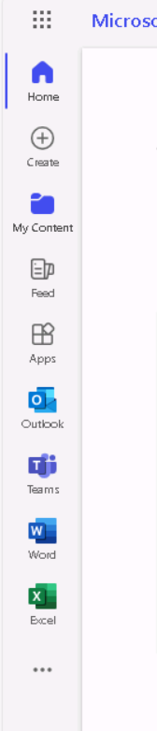
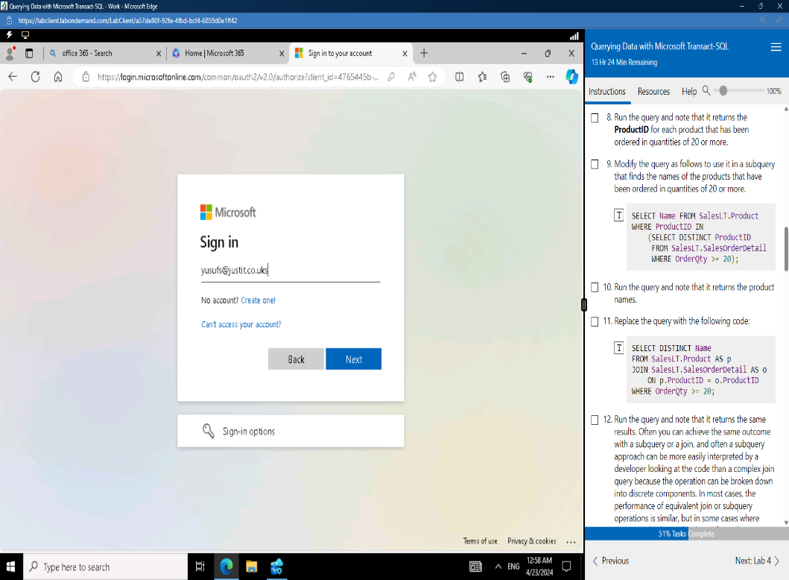

- Sign into Microsoft using bootcamp email id.
- Click on MS Teams on sidebar
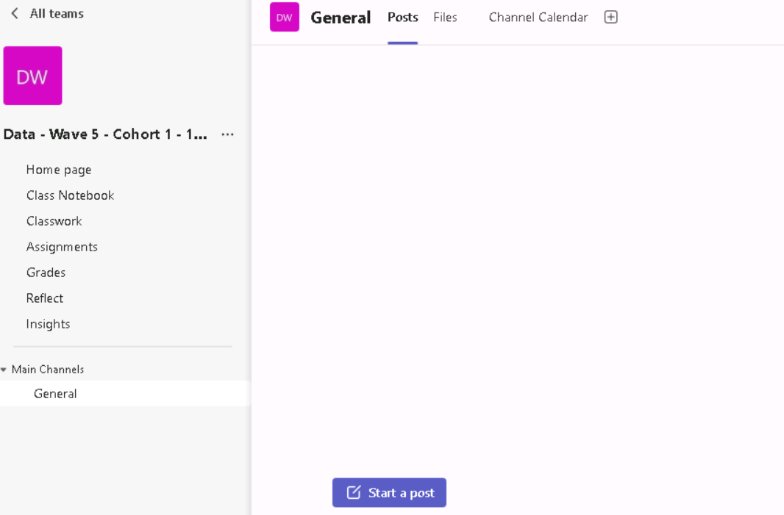
- Go to assignment page in MS Teams channel

- Download ‘Creating Worldb DB file’ from assignment page.
- Start Azure Data Studio and connect to AdventureWorks Schema.
- In this step, you will import and execute ‘Creating Worldb DB file’’.
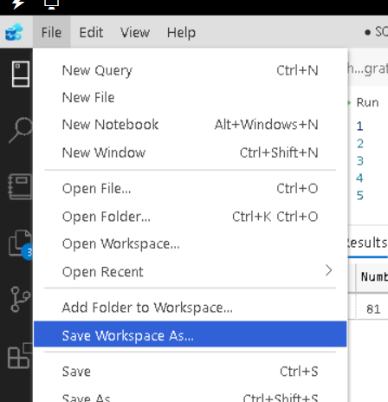
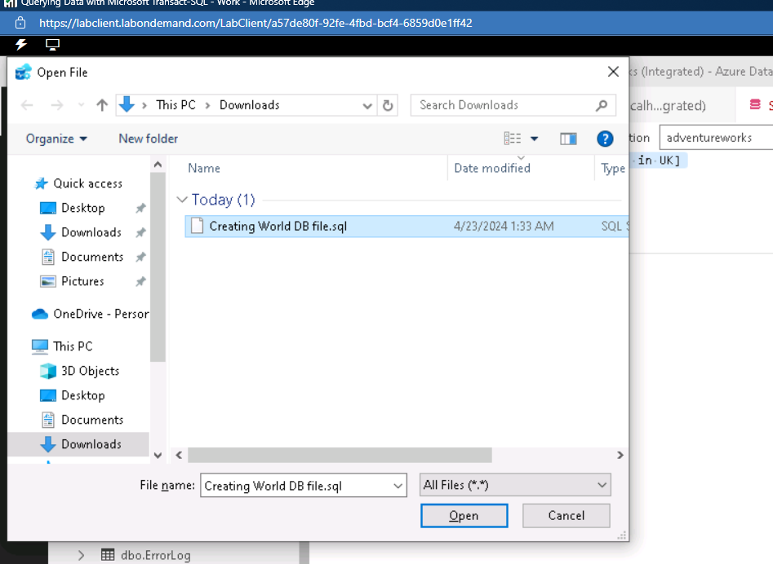
- Go to file > open file in Azure Data Studio
Browse download folder and open Creating Worldb DB. Then click on Run to execute.

- After opening file, click on Run to execute. This will create 3 Tables in AdventureWorks database.

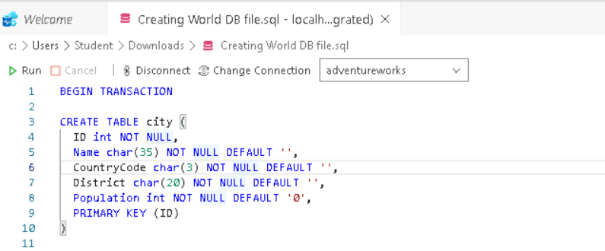

- Expand tables and confirm that dbo.city, dbo.country and dbo.countrylanguage created.
- Create a new query tab to complete tasks.
- You can find tasks in world database tasks file.
- Your submission will only include world database tasks file. Underneath every task you will include screenshot of your query and its result. You will also need to add short comment to explain your query. See example

